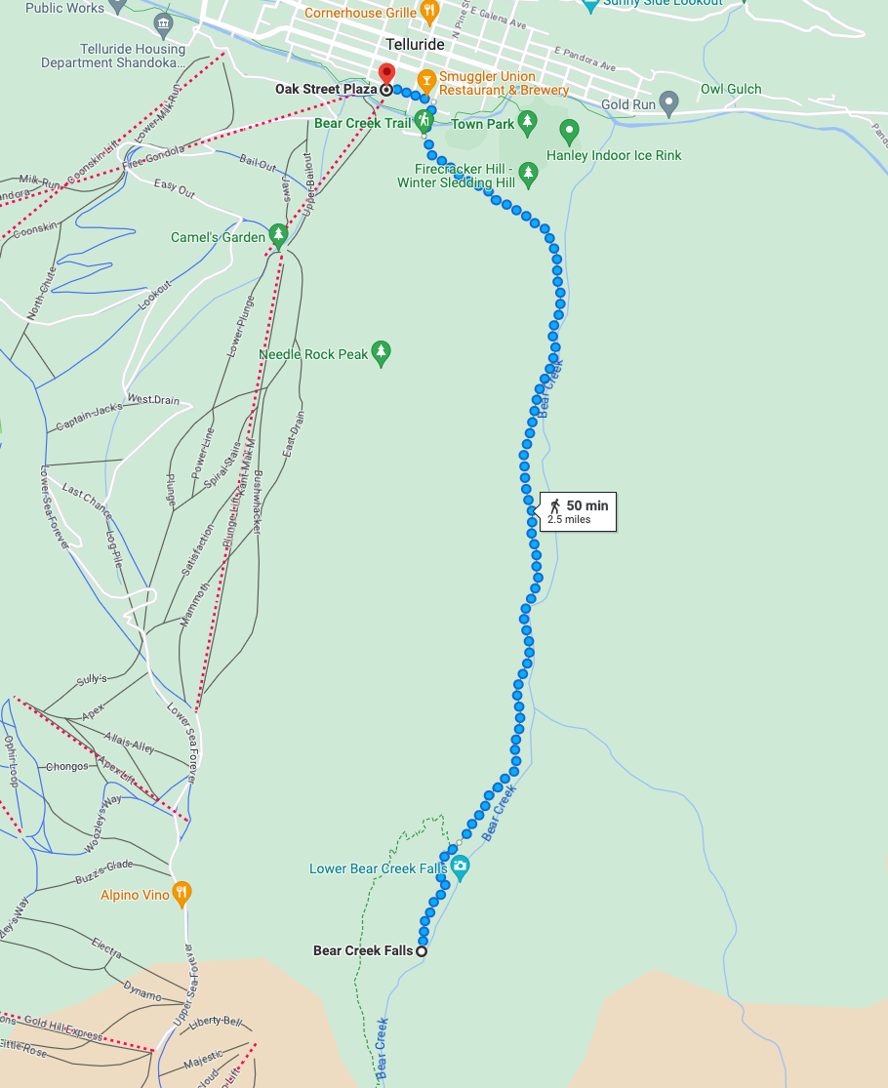

- Starting at Oak Street Plaza (near Gondola): https://goo.gl/maps/ztgkHVYRkSRruP2G8
- Hiking up to Bear Creek Falls: https://goo.gl/maps/AEMLBCPtqoESDfhT8
- Well-deserved “Smuggler Union Restaurant & Brewery” (shown conveniently on the map): https://goo.gl/maps/sVfARtYbFra4LTow6

