**2025 Telluride Conference on Epithelial Physiology and Cell Biology**

**Organizers: Tom Kleyman, My Helms, Aylin Rodan, Pete Snyder**

**Telluride Science and Innovation Center, 300 S. Townsend Street**

**(Samueli Room)**

**____________________________________________________________________________**

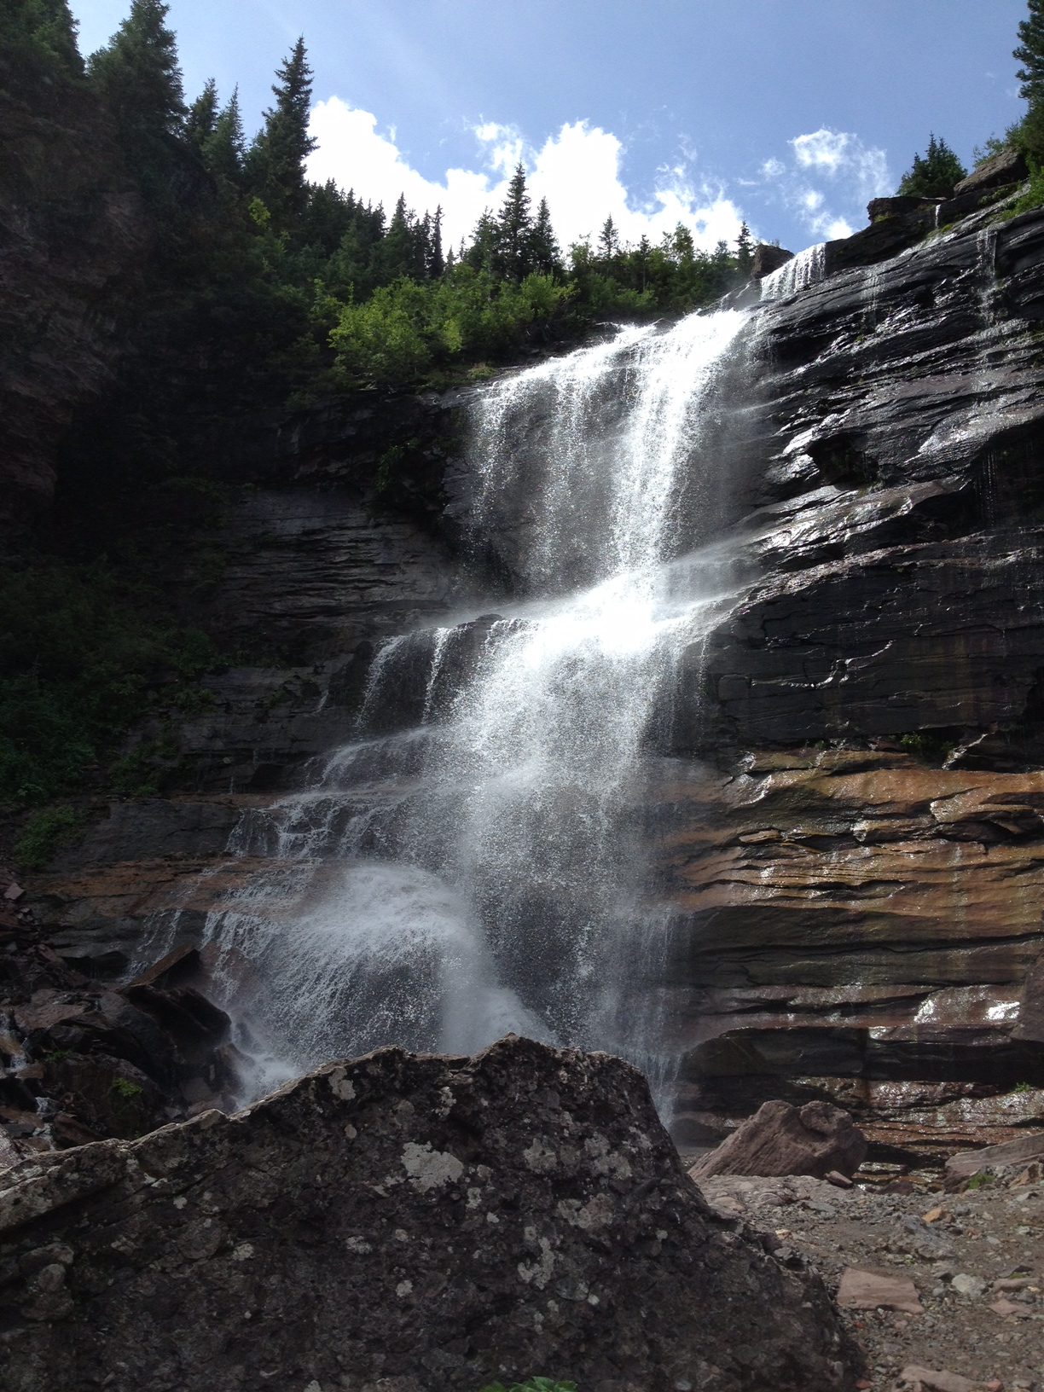**Sunday July 27**

5:00-6:30 PM **TSRC Meet and Greet**

(optional)  
Telluride Science and Innovation Center

**Monday July 28**

1:00-1:10 PM Introduction

1:10-2:00 PM Pete Snyder

2:00-2:50 PM Eric Delpire

2:50-3:20 PM **Break-refreshments**

3:20-4:10 PM Matthias Wolf

4:10-5:00 PM Andrew Nickerson

5:00-5:30 PM Samia Lasaad (virtual)

**Tuesday July 29**

7:30 AM **Breakfast at TSRC**

8:00-8:50 AM Tom Kleyman

8:50-9:40 AM Adriana Girardi

9:40-10:10 AM **Break-refreshments**

10:10--11:00 AM Daniela Rotin

11:00-11:50 AM Doug Eaton

6:30-7:30 PM **Town Talk** (optional)

Telluride Conference Center

Mountain Village

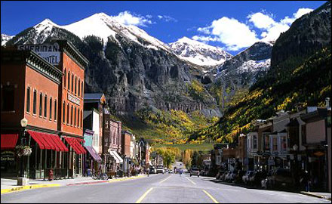

**Wednesday July 30**

**Science hikes**

5:30 PM **Picnic** (open to friends and family)

Telluride Intermediate School tent

**Thursday July 31**

7:30 AM **Breakfast at TSRC**

8:00-8:50 AM Aylin Rodan

8:50-9:40 AM David Pearce

9:40-10:10 AM **Break-refreshments**

10:10--11:00 AM Andrew Terker

11:00-11:50 AM Lama Alqusairi

**Friday August 1**

7:30 AM **Breakfast at TSRC**

8:00-8:50 AM Evan Ray

8:50-9:40 AM Nga Nguyen (virtual)

9:40-10:30 AM My Helms (virtual)