2025 Telluride Conference on Epithelial Physiology and Cell Biology
Organizers: Tom Kleyman, My Helms, Aylin Rodan, Pete Snyder
Telluride Science and Innovation Center, 300 S. Townsend Street
(Samueli Room)
____________________________________________________________________________

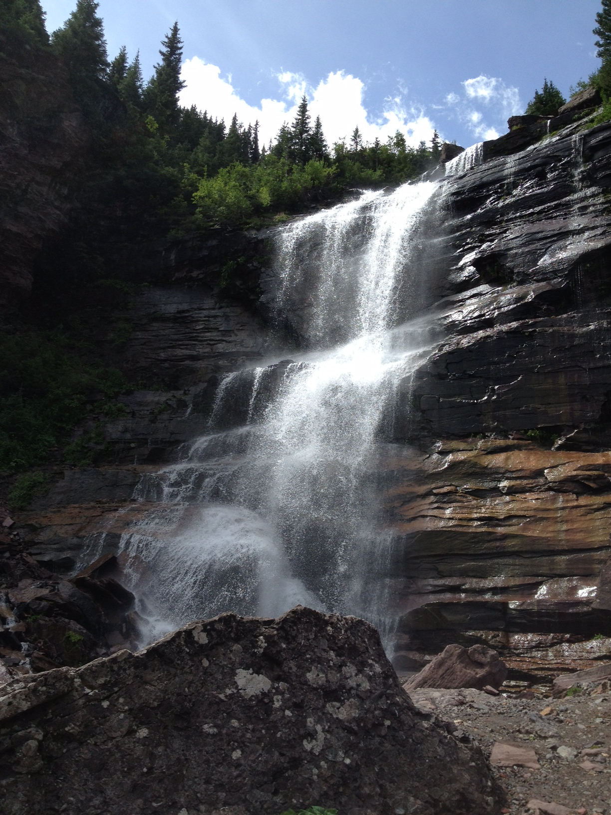
Sunday July 27
5:00-6:30 PM TSRC Meet and Greet
(optional)
Telluride Science and Innovation Center

Monday July 28
1:00-1:10 PM Introduction
1:10-2:00 PM Pete Snyder
2:00-2:50 PM Eric Delpire
2:50-3:20 PM Break-refreshments
3:20-4:10 PM Matthias Wolf
4:10-5:00 PM Andrew Nickerson
5:00-5:30 PM Samia Lasaad (virtual)

Tuesday July 29
7:30 AM Breakfast at TSRC
8:00-8:50 AM Tom Kleyman
8:50-9:40 AM Adriana Girardi
9:40-10:10 AM Break-refreshments
10:10--11:00 AM Daniela Rotin
11:00-11:50 AM Doug Eaton

6:30-7:30 PM Town Talk (optional)
Telluride Conference Center
Mountain Village

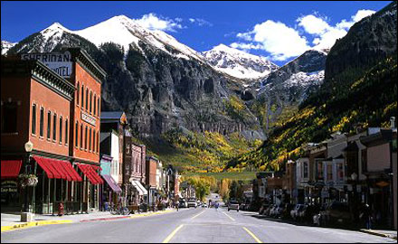

Wednesday July 30
Science hikes

5:30 PM Picnic (open to friends and family)
Telluride Intermediate School tent

Thursday July 31
7:30 AM Breakfast at TSRC
8:00-8:50 AM Aylin Rodan
8:50-9:40 AM David Pearce
9:40-10:10 AM Break-refreshments
10:10--11:00 AM Andrew Terker
11:00-11:50 AM Lama Alqusairi

Friday August 1
7:30 AM Breakfast at TSRC
8:00-8:50 AM Evan Ray
8:50-9:40 AM Nga Nguyen (virtual)
9:40-10:30 AM My Helms (virtual)

