PROGRAM

Telluride Science Research Center
Workshop on Protein Dynamics
July 30 – August 4, 2017

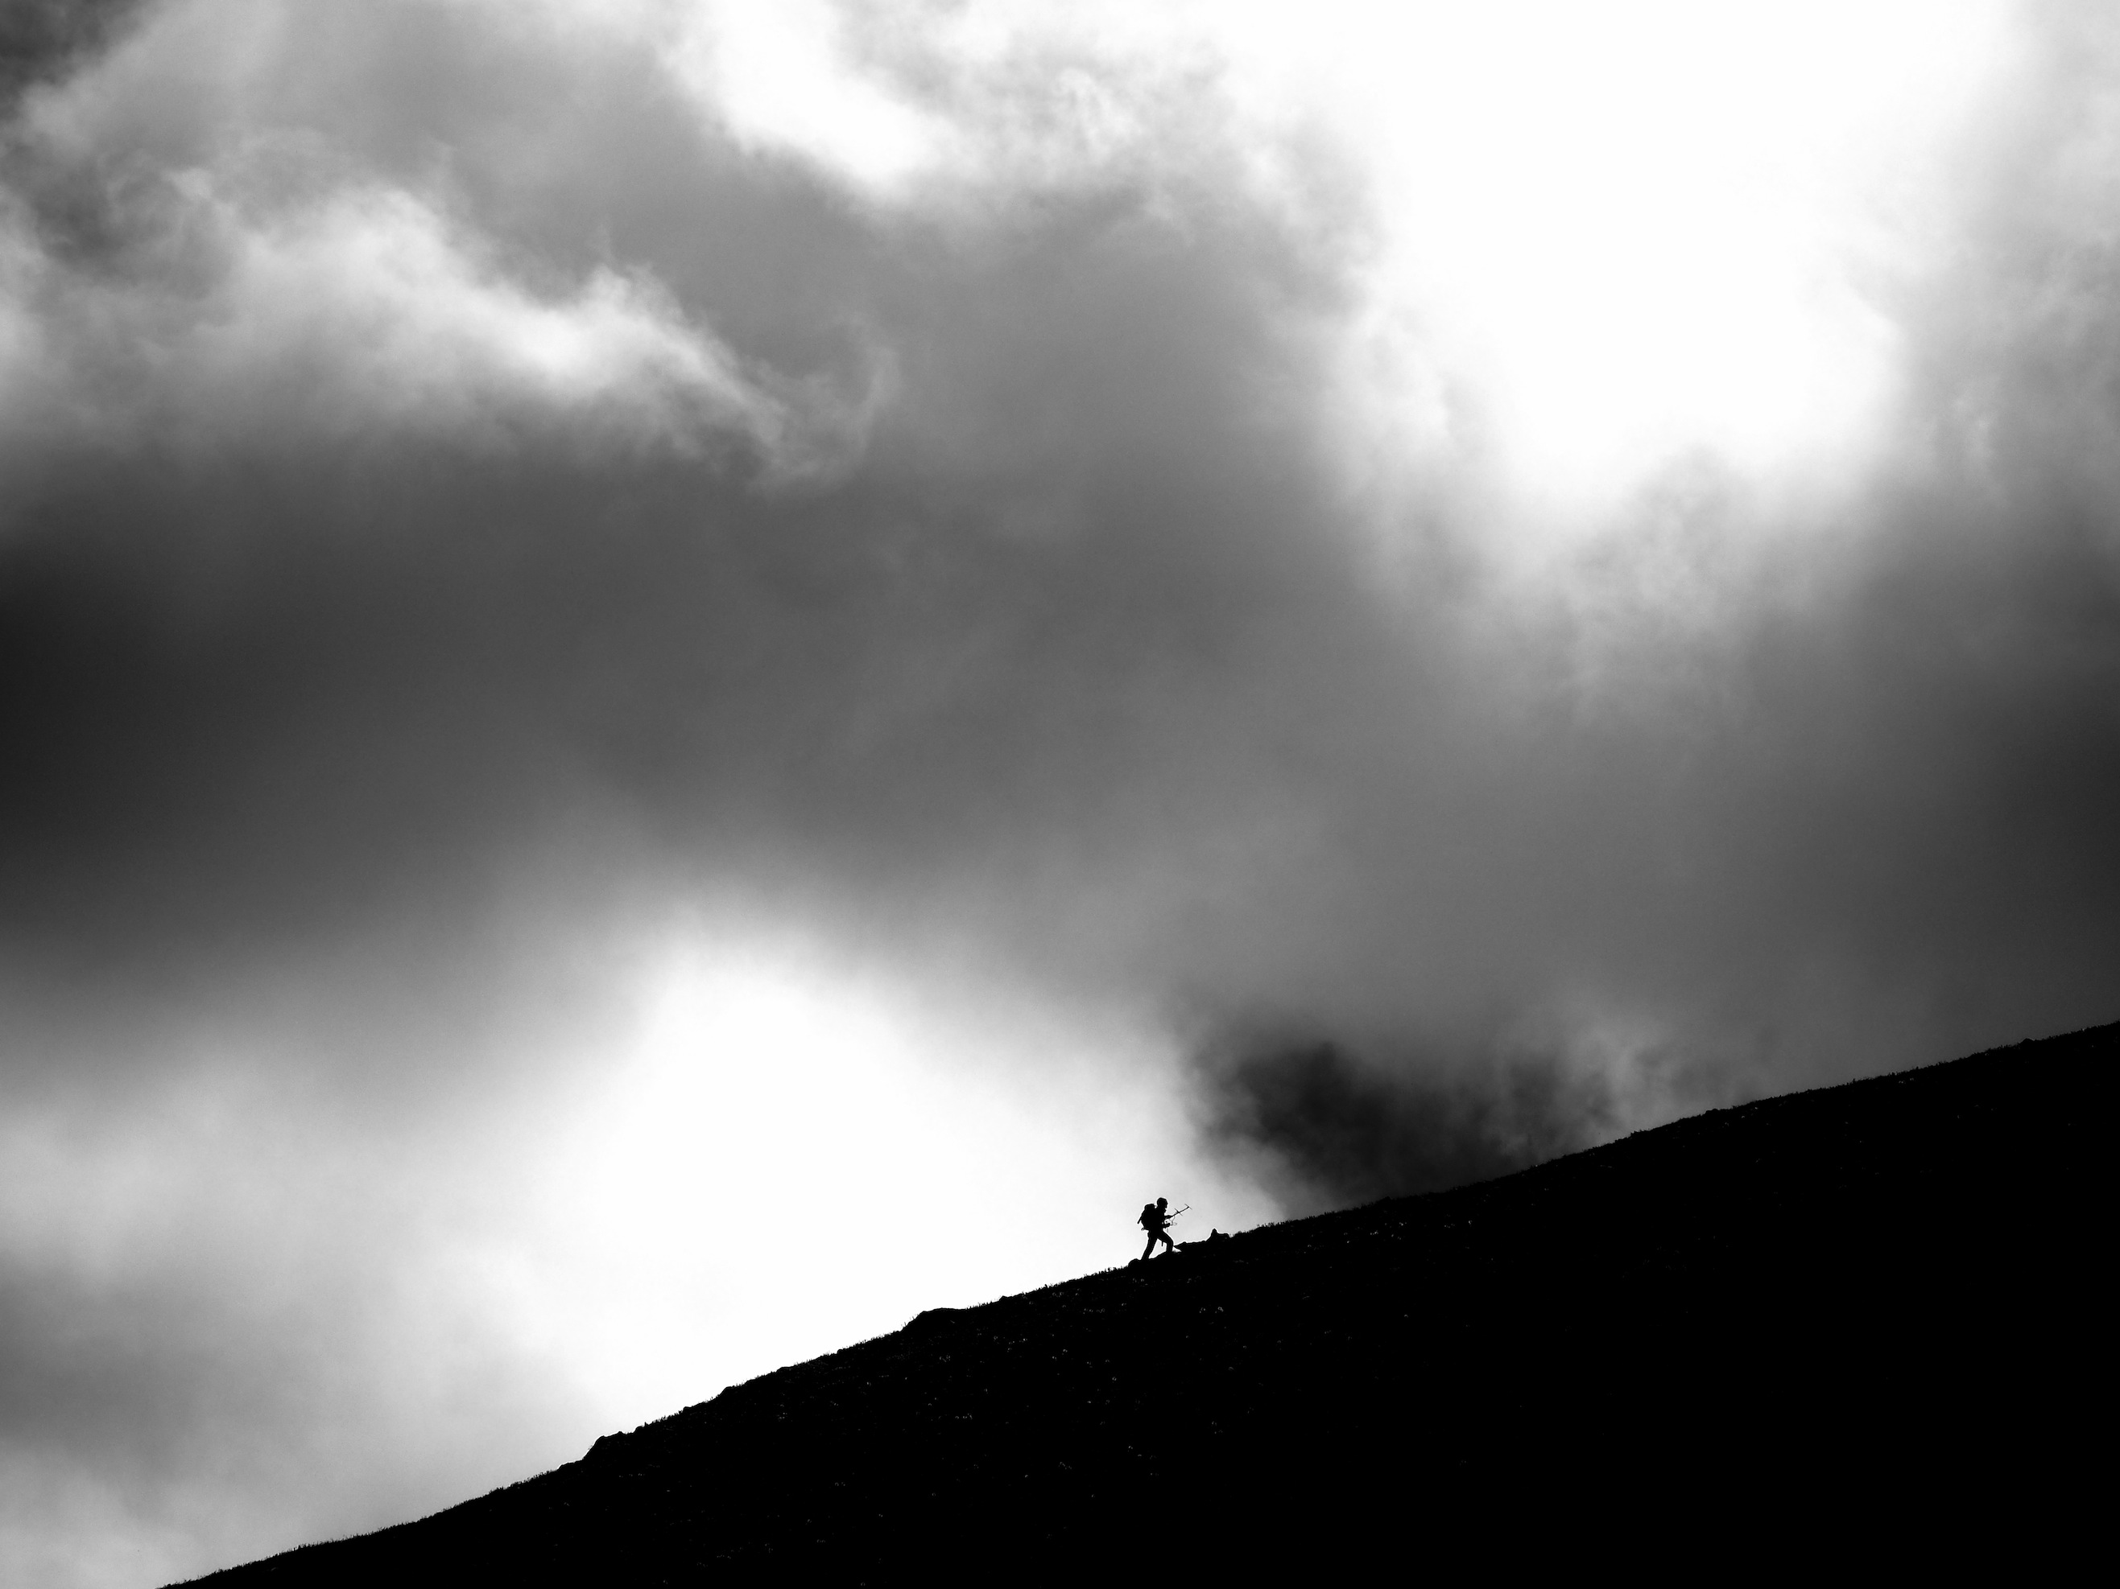

Organizers:

Paul Fenimore Los Alamos National Laboratory
Rafael Brüschweiler The Ohio State University
Takayuki Nishizaka Gakushuin University

TSRC office:

Mark Kozak mark@telluridescience.org / +1 970 708 4426

Location of the meeting and breakfast:
Telluride Intermediate School 725 West Colorado Ave, Telluride

Participants
- Anfinrud, Philip - National Institutes of Health (USA)
- Blackledge, Martin - Institut de Biologie Structurale (FR)
- Brüschweiler, Rafael - Ohio State University (USA)
- Fenimore, Paul - Los Alamos National Laboratory (USA)
- Fonseca, Rasmus – Stanford University (USA)
- Frauenfelder, Hans - Los Alamos National Laboratory (USA)
- Havenith, Martina - Bochum University (DE)
- Hayashi, Shigehiko – Kyoto University (JP)
- Head-Gordon, Teresa – University of California, Berkeley (USA)
- Kitao, Akio - The University of Tokyo (JP)
- Lindorff-Larsen, Kresten - Copenhagen University (DK)
- Nishizaka, Takayuki - Gakushuin University (JP)
- McDermott, Ann - Columbia University (USA)
- Meuwly, Markus – University of Basel (CH)
- Mizutani, Yasuhisa - Osaka University (JP)
- Oroguchi, Tomotaka - Keio University (JP)
- Palmer, Arthur - Columbia University (USA)
- Sage, J Timothy - Northeastern University (USA)
- Straub, John - Boston University (USA)
- Thielges, Megan – Indiana University (USA)
- Tobias, Doug – University of California, Irvine (USA)
- Uchihashi, Takayuki – University of Kanazawa (JP)
- van Thor, Jasper - Imperial College London (UK)
- Weik, Martin - Institut de Biologie Structurale (FR)
- Yamato, Takahisa - Nagoya University (JP)

Sunday, July 30

14:00-17:00 Summer School Mini-Symposium: Rm. 224 Intermediate School
Biomolecular Structure and Dynamics: Theory and Experiment

17:00 Reception: Telluride Intermediate School, Eastside tent

Monday, July 31

8:00-8:20 Breakfast
8:20-8:30 Welcome

Session Chair: Paul Fenimore

8:30-9:15 Tobias, Doug
Simulation studies of protein interactions, organization, and dynamics in crowded solutions

9:15-10:00 Kitao, Akio
Dissociation and association dynamics of proteins

10:00-10:30 Break

10:30-11:15 Thielges, Megan
Dynamics of protein molecular recognition by 2D IR spectroscopy

11:15-12:00 McDermott, Ann
The signaling complex in necroptosis is a structurally novel amyloid

Lunch break

Session Chair: Rafael Brüschweiler

14:30-15:15 Havenith, Martina
Water mapping by THz calorimetry

15:15-16:00 Oruguchi, Tomotaka
Protein conformational fluctuations and hydration structures investigated by the combination of MD simulations and X-ray experiments

16:00-16:45 Fenimore, Paul
Hydration water structures

Tuesday, August 1st

Session Chair: Takayuki Nishizaki

12:00-12:45 Brüschweiler, Rafael
Dynamics of function-critical protein states: enzymes, loops, and IDPs

12:45-13:30 Head-Gordon, Teresa
Statistical fluctuations, dynamics, scaffolds, electric fields, and de novo enzyme catalysis

13:30-14:00 Break

14:00-14:45 Lindorff-Larsen, Kresten
From protein folding to patient diagnosis

14:45-15:30 Blackledge, Martin
Large scale protein dynamics - from fundamental biophysics and biological function

15:30-15:50 Break

15:50-16:35 Palmer, Arthur
Spin relaxation in proteins: methods and applications

16:35-17:20 Mizutani, Yashuhisa
Importance of atomic contacts to propagations in protein: functional compactness

18:00-19:00 Town Talk at the Conference Center in Mountain Village.
Allow 35 minutes to travel there. Cash bar opens at 17:30.

Wednesday, August 2nd

8:00-8:30 Breakfast

Session Chair: Doug Tobias

8:30-9:15 Anfinrud, Phil
Time-resolved x-ray and NMR studies of biomolecules: from folding to function

9:15-10:00 Uchihashi, Takayuki
Direct visualization of single molecule dynamics by high-speed atomic force microscopy

10:00-10:30 Break

10:30-11:15 Nishizaki, Takayuki
Development of imaging techniques to reveal single-protein dynamics and their application to microbiology

11:15-12:00 Weik, Martin
Time-resolved serial femtosecond crystallography on photoswitchable fluorescent proteins

Lunch break

Session Chair: Martina Havenith

14:30-15:15 Frauenfelder, Hans
The spatial diffusion and the energy landscape model for thermal neutron scattering

15:15-16:00 Sage, Timothy
Influence of vibrational and supravibrational dynamics on nuclear resonance absorption

16:00-16:30 Break

16:30-17:15 Fonseca, Rasmus
Efficient conformational interpretation of DEER using structural and dynamic constraints

17:15-18:00 Meuwly, Markus
Protein metastable states from atomistic simulations

18:00-20:00 Picnic at the Telluride Intermediate School

Thursday, August 3

Session Chair: Phil Anfinrud

14:30-15:15 van Thor, Jasper
Approaches to study exciton dynamics and charge separation in photosynthesis

15:15-16:00 Yamato, Takahisa
Forced unfolding mechanism of bacteriorhodopsin as revealed by coarse-grained molecular dynamics

16:00-16:30 Break

16:30-17:15 Hayashi, Shigehiko
Understanding and Designing Color Variants of Retinal Binding Proteins by Molecular Simulations

17:15-18:00 Straub, John
The role of lipid composition, domains, and interfaces in membrane protein structure and function

18:00-19:45 Casual dinner at the school will be arranged and business meeting. TBA during the workshop with participants.

19:45-20:00 Closing remarks

