2018 Telluride Conference on Epithelial Physiology and Cell Biology
Organizers: Tom Kleyman, My Helms, Pete Snyder
Telluride Intermediate School (TSRC)
725 West Colorado Avenue
____________________________________________________________________________

Monday July 23
12:30-1:20 PM My Helms
1:20-2:10 PM Aylin Rodan
2:10-2:40 PM Break-refreshments
2:40-3:30 PM Alan Pao
3:30-4:20 PM Carolyn Ecelbarger
4:20-4:30 PM Break
4:30-5:00 PM Amity Eaton
5:00-5:50 PM Jeff Garvin

Tuesday July 24
7:30 AM Breakfast at TSRC
8:00-8:50 AM Daniela Rotin
8:50-9:20 AM Jordan Juarez
9:20-9:40 AM Break-refreshments
9:40--10:30 AM Rebecca Hughey
10:30-11:20 AM Tom Kleyman
11:20-11:30 AM Break
11:30-12:20 PM Abdel Alli

6:30-7:15 PM Town Talk
Telluride Conference Center in
Mountain Village
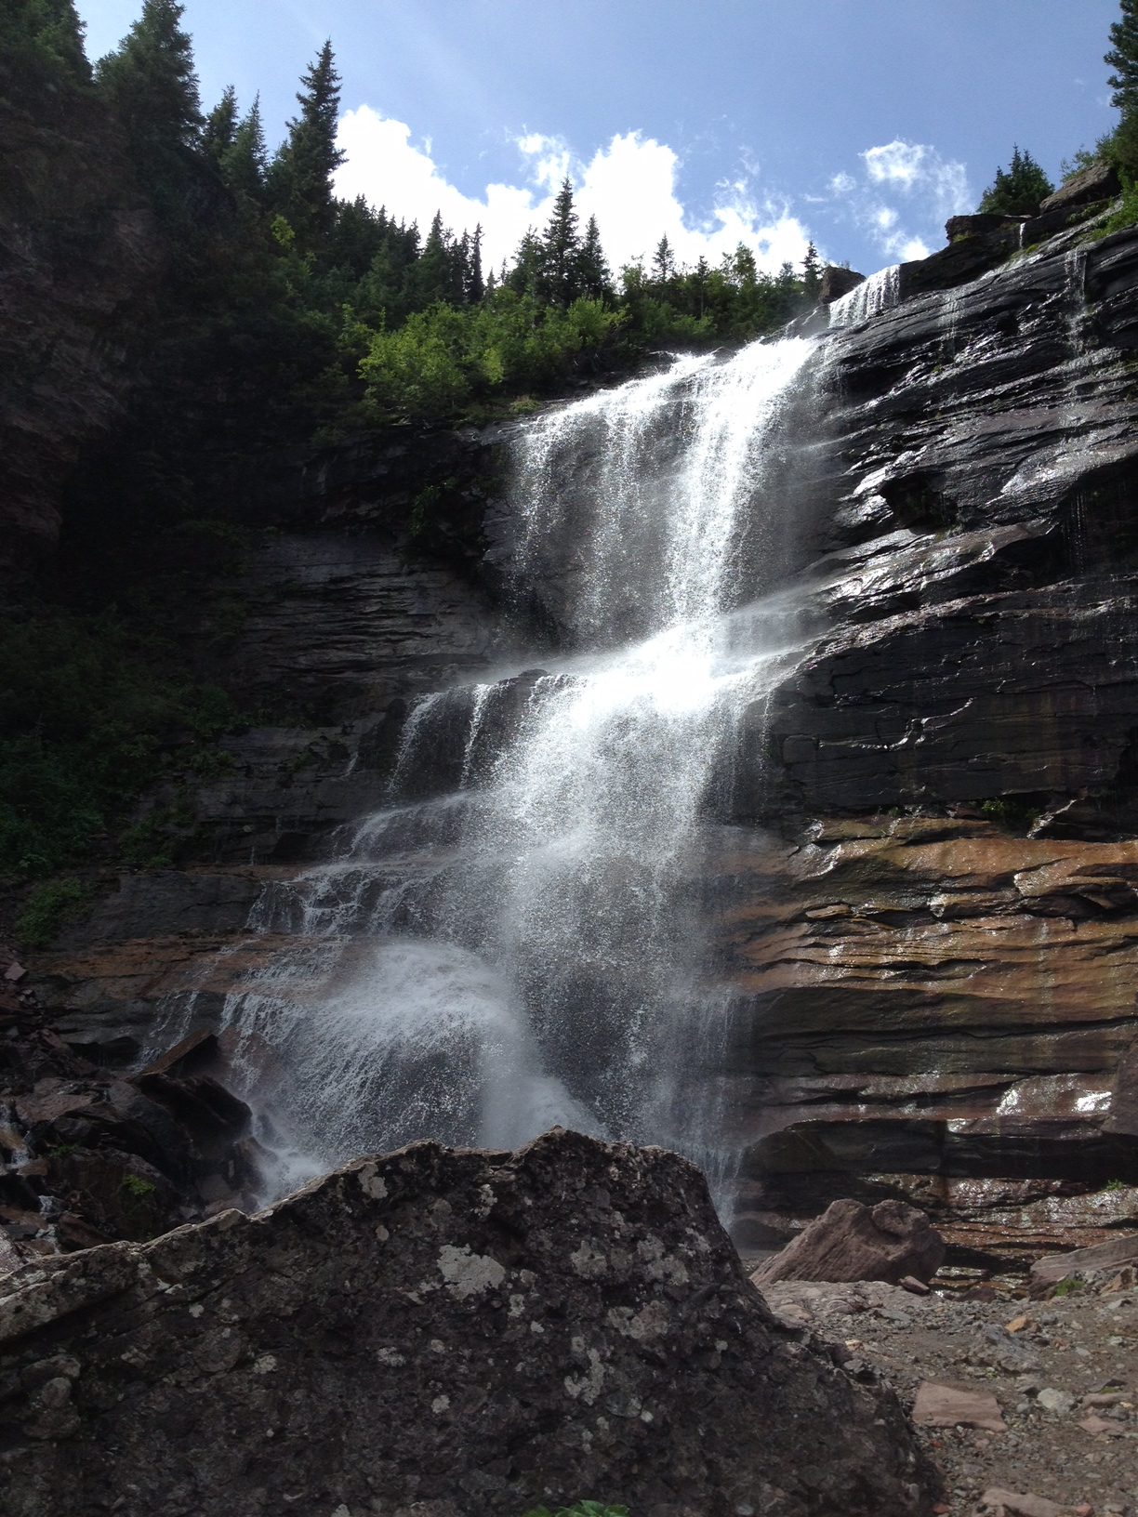
“Geo-Engineering a Climate Change Solution"
Frank Keutsch, Harvard University

Wednesday July 25
Group Science Hike

6:00 – 9:00 PM Picnic
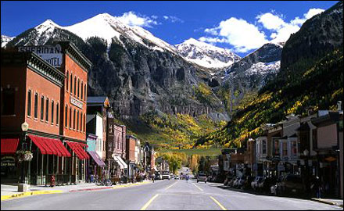
Thursday July 26
12:30-1:20 PM James McCormick
1:20-2:10 PM WenHui Wang
2:10-2:40 PM Break-refreshments
2:40-3:30 PM Doug Eaton
3:30-4:20 PM Nazih Nakhoul
4:20-4:30 PM Break
4:30-5:20 PM Matthias Wolf

Friday July 27
7:30 AM Breakfast at TSRC
8:00-8:50 AM Arohan Subramanya
8:50-9:40 AM Daria Ilatovskaya
9:40-10:10 AM Break-refreshments
10:10-10:40 AM Kubra Tuna
10:40-11:30 AM Pete Snyder

